# 2024 Annual Report Instructions

Thank you for your cooperation in completing the 2024 DEAC Annual Report. We are excited to share that plans are already underway for a new, state-of-the-art data collection portal. Launching in 2026, this portal will feature modern architecture, a user-friendly interface, and enhanced scalability to meet DEAC's evolving needs. Our goal is to provide a system that not only streamlines data entry but also empowers schools to strengthen their institutional effectiveness practices.

We have opted to transition this year's data collection process to spreadsheets. While this temporary approach may differ from previous years, it will allow us to gather the necessary information effectively and ensure a smooth transition to our upcoming system upgrade.

The following instructions will guide you through the process of completing and submitting your spreadsheets. Your attention to detail and timely submission will help us ensure accuracy and continuity during this interim period. Thank you for your continued commitment to DEAC’s mission and standards.

When you open the Excel spreadsheet, you will see six tabs for your information.



Some information from your data submittal from 2023 will be pre-populated within the document, such as program names and enrollment numbers from 2023. New schools will only have their approved programs included.

## Institutional Information

New institutions: fill out as much of the information as applicable.

Existing schools: update any information as applicable.

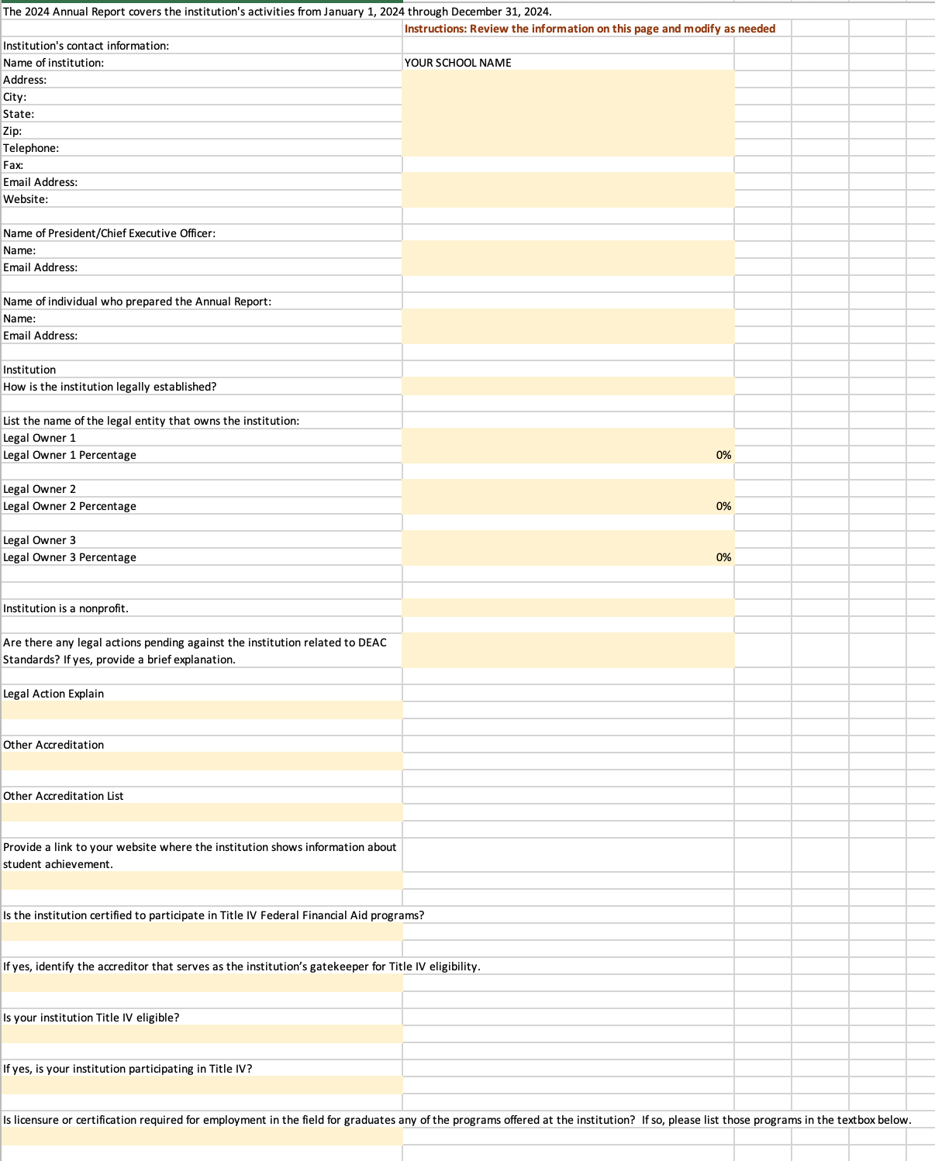State Authorization Dist. Ed. Tab

New schools: fill out the information for each state.

Existing schools: update your information as applicable.

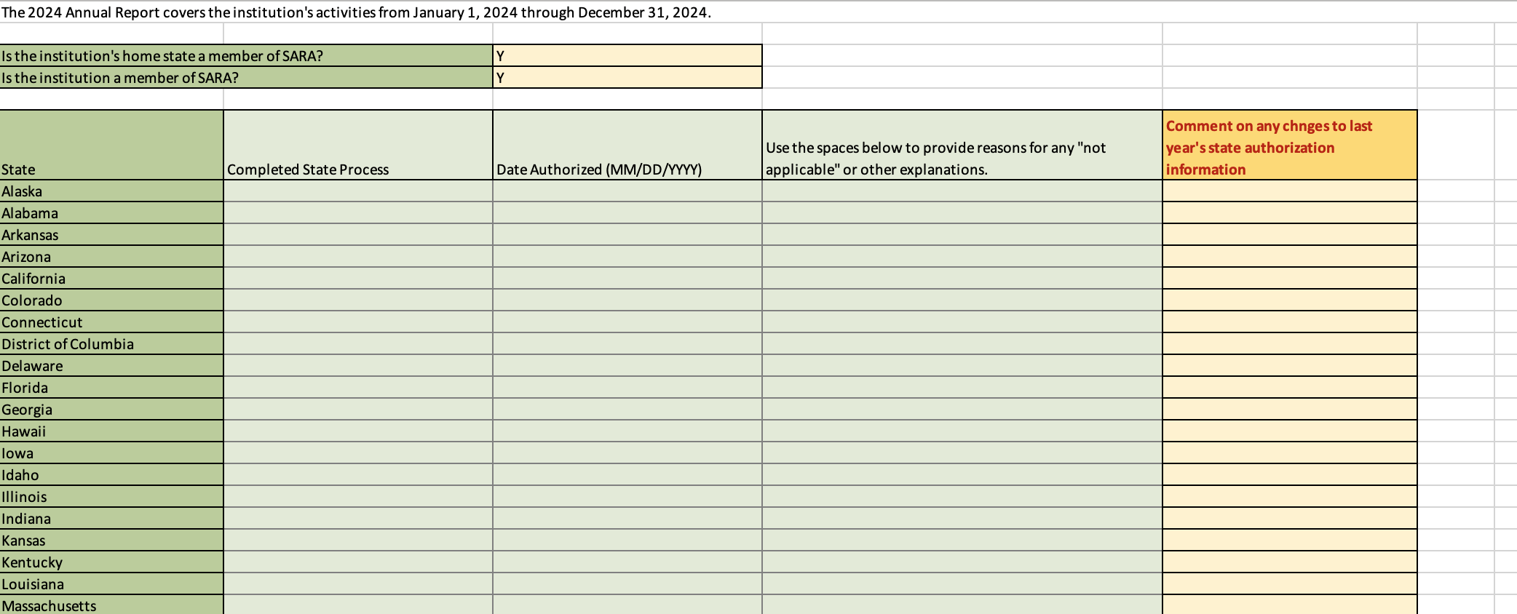

## Programs Tab

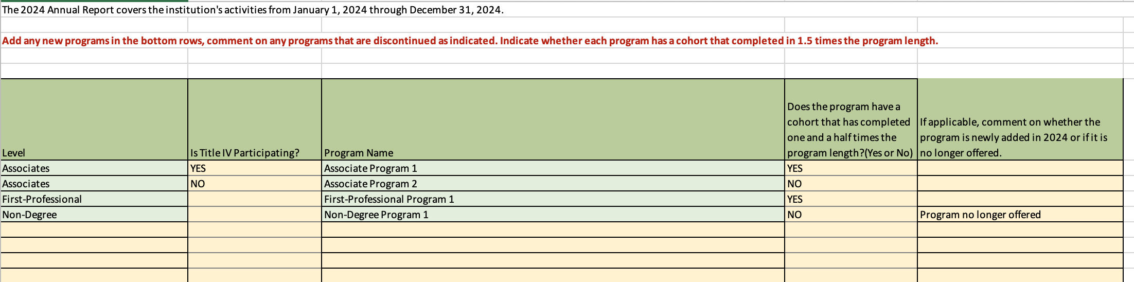

This tab is pre-filled with the information from your 2023 annual reports. For new schools, your pre-approved programs are pre-filled. Only the yellow cells on this tab are editable for you. You may add any newly approved programs after the last green entry.

If your program is an Associates program, please be sure to use the drop-down menu in each cell of Column B to indicate whether the program is Title IV or not.

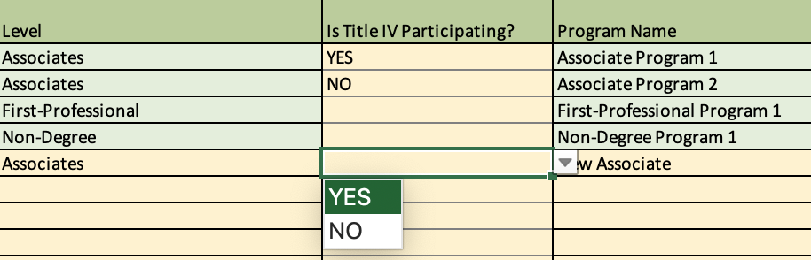

In column D, indicate whether the program has had a cohort that had students that completed within 1.5 times the program length. For example, if the program is designed as a two-year program, for 2024, you will be reporting on students who started their program in 2021. This column also utilizes a drop-down menu with YES or NO responses.



## Enrollment Tab

This tab pre-fills your program names and levels. Only the data input cells are editable.

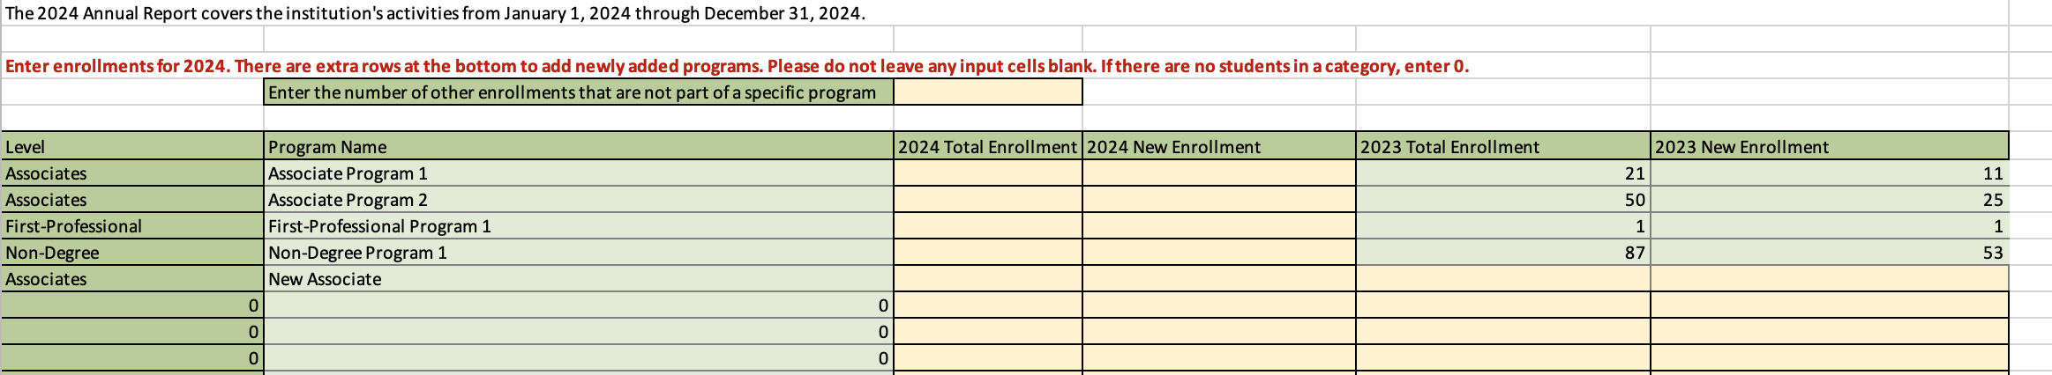

First you want to enter the number of any students who are enrolled, but not part of a particular program. This may include students who are just wanting one class but not to enroll in a program. Not all institutions make single enrollments available to students. If the number is 0, then enter 0.

Second, please enter the total number of students enrolled in each program regardless of cohort.

Third, enter the number of students who enrolled during 2024 regardless of cohort.

Keep in mind: For each program DO NOT leave any input cells blank. Enter values that are greater than or equal to 0 only. Also, the number of Total students should be greater than the number of New students.

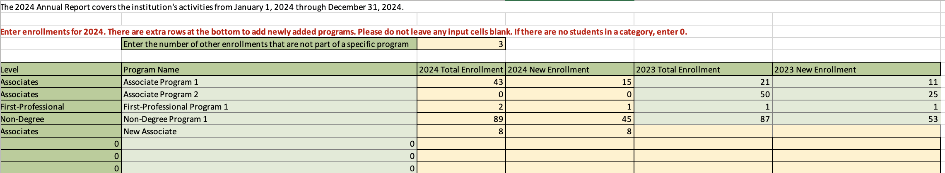

## Completion Rates

The Completion Rates tab is pre-populated with your Institution Name, and Program Names and levels. It will also be populated with any new programs you added in the “Programs” tab. In this tab you will fill out your cohort information.

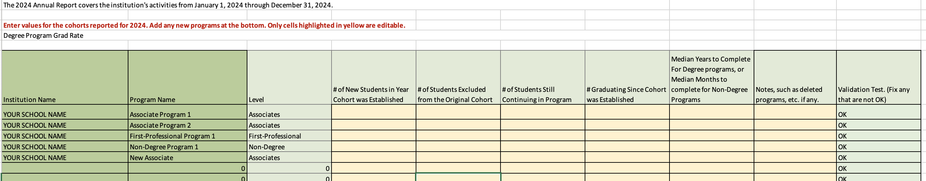

In column D, provide the number of new students who enrolled in the year the cohort was established. For example, for the example of a two-year program that started in 2021, you will fill in how many students enrolled in that program back in 2021.

In column E, you will provide any exclusions, which should include any students who were removed from the cohort who died or were totally and permanently disabled; students who left school to serve on active duty in the armed forces; students who left school to serve with a foreign aid service; or those who left to serve on official church missions.

In column F, provide the number of students from the cohort being reported who are still continuing in the program.

In column G, provide the number of students from the cohort who graduated. That is, for our example of the two-year cohort starting in 2021, you will provide the number of students who enrolled in 2021 and have graduated as of 2024.

Column H:

* For degree programs, provide the median number of *years* students have historically taken to complete the degree program. For example, if the program is a two-year program and the median number of years students take to complete it is 3.7, then enter 3.7.
* For non-degree programs, provide the median number of *months* students have historically taken to complete the degree program. For example, if the program is a 6-month program and the median number of months students take to complete it is 7.2 then enter 7.2.

Column I, you have the option to enter any notes that you have regarding the program, such as if the program is no longer offered, indicate so.

Column J is not -editable. The column should say “OK”. If it doesn’t say “OK”, then there is a problem with your data entry. For example, if you say there were 10 students in the original cohort, with 3 exclusions, 5 still continuing, and 4 graduates, you will have an error since the number of exclusions plus still continuing plus number graduating (=12) exceeds 10. Please correct such errors.

For all data in this tab, enter a value in each numeric input cell that is greater than or equal to 0. It is important to not leave blanks since when the data are analyzed, the analyst cannot determine whether you mean 0 or you simply missed a data point.

## Narrative Tab

Please respond to each DEAC question in this tab. The entire sheet is editable, but please do not edit the prompts.

